CONFIRMATION OF THE DATES OF THE PERIOD FOR THE EXERCISE OF PUBLIC RIGHTS

Name of smaller authority: OFFORD CLUNY & OFFORD DARCY PARISH COUNCIL

County Area (local councils and parish meetings only): CAMBRIDGESHIRE

On behalf of the smaller authority, I confirm that the dates set for the period for the exercise of public rights are as follows:

Commencing on Monday June 4, 2018

and ending on Friday July 13, 2018

(Please enter the dates set by the smaller authority as appropriate which must be 30 working days inclusive and must include the first 10 working days of July 2018.
We have suggested the following dates: Monday 4 June – Friday 13 July 2018.
The latest possible dates that comply with the statutory requirements are Monday 2 July – Friday 10 August 2018.)

Signed: 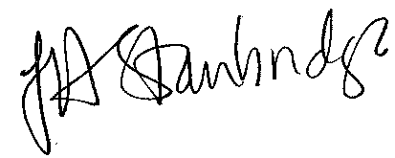

Role: Clerk to the Council/RFO

PLEASE SUBMIT THIS FORM TO PKF LITTLEJOHN LLP WITH THE AGAR AND OTHER REQUESTED DOCUMENTATION

