CONFIRMATION OF THE DATES OF THE PERIOD FOR THE EXERCISE OF PUBLIC RIGHTS

Name of smaller authority: OFFORD CLUNY & OFFORD DARCY PARISH COUNCIL

County Area (local councils and parish meetings only): CAMBRIDGESHIRE

On behalf of the smaller authority, I confirm that the dates set for the period for the exercise of public rights are as follows:

Commencing on Monday July 6, 2020

and ending on Friday August 14, 2020

Signed: 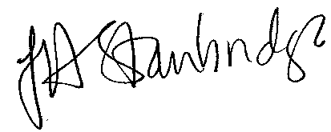

Role: Clerk to the Council/RFO

PLEASE SUBMIT THIS FORM TO PKF LITTLEJOHN LLP WITH THE AGAR AND OTHER REQUESTED DOCUMENTATION

