Offord Cluny & Offord Darcy Parish Council
The Village Hall
158 High Street
Offord Cluny
St Neots
Cambs PE19 5RR
Clerk@offords-pc.gov.uk
www.offords-pc.gov.uk
07597 988763

Parish Council Report to the Residents of the Offords - 9th February 2021

This is a report of the latest news concerning the flood related challenges facing many of our residents plus details of where and how to get more information and help, if needed.

The flooding of houses in Offord Cluny on the night of 23rd December was a very serious incident, with many residents having to abandon their homes for several months whilst remedial work is carried out. The Parish Council have conducted several interviews with those affected by the flooding and have produced a report to our District and County Councils giving details of the affected areas along with our opinions of the causes and suggestions for possible mitigation measures in the future.

The Offords escaped the fate of many local towns and villages – that of surface water flooding due to inadequate or overwhelmed street drainage. About 2 years ago much of the under-road drain channelling was replaced along the Graveley Road and into the High Street. Only a few weeks previously the gullies along the High Street were cleared. Consequently, there was no significant surface water flooding in either the Graveley Road or most of the High Street itself – a particularly good thing since many of the older properties situated alongside have front doors with exceptionally low thresholds that open directly at street level and have suffered flood damage in the past.
There were three areas within the village that were severely affected by flooding, the causes of which were not directly related but all appeared to be consequences of neglected drainage systems:

- Houses in Latin Close and Park Way. The worst-hit area, this appeared to be a consequence of the Brook being blocked by falling trees and vegetation further up. When the bank inevitably burst, an exceptionally large volume of water flowed down towards the High Street, flooding some 20 properties in Latin Close and Park Way with others having flooded garages, outbuildings and gardens. The Brook has now been cleared of this major blockage, but work remains to be done to clear minor obstructions further downstream

- The Bungalow in Station Lane adjacent to the Level Crossing has been quite badly hit by successive flooding episodes. The main cause would appear to be the blockage to the section of the Brook that runs underneath the railway lines. Network Rail have been notified and are currently scoping the extent of the work required. There are some other obstructions that will be the responsibility of the Parish Council to clear.

- 237 High St Offord Cluny (and adjacent properties). These houses are at the beginning of Offord Cluny, at the bottom of Offord Hill. Initially it seemed that the impact was relatively minor, centering on no 237, but the water did not drain away and subsequent rainfall has threatened the whole row with water ingress into their properties. All this exacerbated by the sewage pumping system which has left that part of the village unable to use toilets or washing facilities until Anglia Water can clear the system. Additionally, surface water has severely damaged the road and necessitated its periodic closure – a major issue for residents of the Offords.

Whilst as a Parish Council we have truly little in the way of powers of enforcement, we have been acting as an information conduit, helping to coordinate actions from several of the responsible Agencies. We have been in constant contact with both County and District Councils, the Police and the Fire Service, Cambridge County Highways, Highways England, Anglian Water, the Environment Agency, Network Rail and a variety of Landowners as well as the affected residents. One thing that is clear is that to prevent this kind of incident in the future (which was widespread throughout the locality) a plan that coordinates the efforts of the responsible parties rather better than on this occasion is vital.

In the immediate aftermath of the flooding of 23rd December, several parties got together and started the process of coming up with a plan. Broadly speaking the following conclusions were arrived at:

- the Environment Agency has to control the flow of the river as far as it can and give warnings in good time;
- Anglian Water has to be able to guarantee the separation of sewage drains from surface drainage
- the County Council has to improve its performance in clearing drains (it had reduced this programme as a cost-cutting measure);
- the District Council has got to think more carefully about flooding risk when giving planning permission and developers need to be required to include professionally designed flooding mitigation.
- Parish Councils need to know precisely where the areas of greatest risk are and have emergency measures in place e.g., community venues where displaced persons can take refuge;
- The need for Landowners who are the ‘riparian owners’ of the ditches and brooks on their land and are responsible for their maintenance to adequately maintain them;
- Houseowners have to be aware of the risk, acknowledge their primary responsibility to protect their own premises and have emergency sandbags, vent covers available if serious flooding threatens.
Ian Weitzel
Chair of the Parish Council of Offord Cluny and Offord Darcy

Additional Help and Advice for Residents

In addition to the Parish Council, whose contact details are above, these are the details of organizations who can provide help and advice and specific flood related issues.

Sewage Problems Anglian Water 03457 145145
https://www.anglianwater.co.uk/help-and-advice/report-an-issue/

Blocked Drains or Road issues Cambs Highways 0345 0455212
https://highwaysreporting.cambridgeshire.gov.uk/

Surface Water caused by rain CCC Flood Risk & Biodiversity Team 0345 0455200
floodwater@cambridgeshire.gov.uk

Large Rivers Environment Agency 0345 9881188
enquiries@environment-agency.gov.uk

Small Rivers/Drainage Ditches Huntingdon District Council 01480 388388
mail@huntingdonshire.gov.uk

In addition to the Parish Council website www.offords-pc.gov.uk and the village notice boards, the best way to keep up to date with what is happening in the Offords is Facebook, where there is an Offords page, and the Offord Community Support Group, both of which are updated frequently.

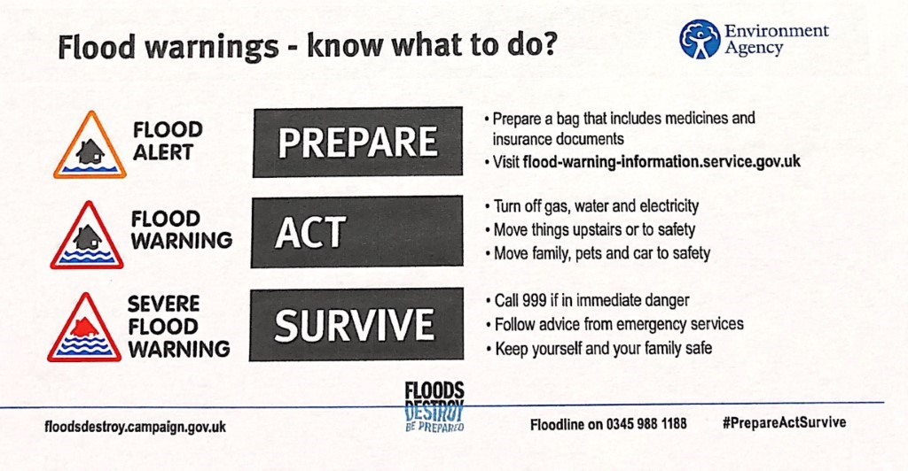

STOP PRESS

PLEASE REDUCE WATER USAGE WHEREVER POSSIBLE

The process by which waste water is taken away from the Offords is under great pressure. Anglian Water have provided additional pumps and are pumping water away from at risk properties. Overnight last night they pumped over 1 million litres (FIVE times more than usual). So far, it has had a small but positive impact on those houses at most risk of flooding. The request from the Parish Council is to reduce your use of water whenever possible, for example, consider alternate day showers and how often you need to flush the toilets. However, in line with COVID recommendations you must continue with frequent and adequate hand washing. Even a small reduction by each household will have a positive effect. Thank you.

TURN OFF WATER SUPPLIES

If you have outside taps, consider turning them off in this cold weather so that the pipes do not burst. If you must leave your house empty, do make sure that you turn off the mains water supply.

PLEASE DO NOT DRIVE THROUGH THE ROAD CLOSURE ON THE HIGH STREET

The north end of the High Street is at most risk of further flooding at the moment. The road is closed but many motorists are ignoring the signs and driving through. The result is a wave of water from each car into properties which are within inches of flooding. Please take the time drive the long way around and spare a thought for those residents whose homes are at risk. Thank you.

IMPORTANT: Delivery of Paper Copies of PC Reports in the Future

Please Respond Or You Will No Longer Receive A Paper Delivery To Your Door!

The Parish Council plan to continue producing information about flooding and actions being taken to reduce the risk of this happening in the future. This will be available on the Offord Cluny and Offord Darcy Parish Council website (offords-pc.gov.uk).

If you would prefer a paper copy then please complete your details below and put the slip into the Offord Cluny and Offord Darcy Parish Council mailbox on the outside wall of the Village Hall to the left of the doors. Alternatively email your details to Clerk@offords-pc.gov.uk

Name : _______________________________________

Address :
______________________________________________________________________

Please note that copies will be hand delivered to addresses only within Offord Cluny and Offord Darcy.

By returning this form you are accepting that Offord Cluny and Offord Darcy Parish Council will be keeping a record of your name and address. You can request the record to be removed at any time either by email to clerk@offords-pc.gov.uk or in writing to Offord Cluny and Offord Darcy Parish Council, The Village Hall, 158 High Street, Offord Cluny, St Neots, PE19 5RR

