Offord Cluny & Offord Darcy Parish Council

Minutes of a MEETING of the Parish Council held on Thursday, July 6, 2023 at the Village Hall, Offord Cluny commencing at 7.30pm

Present: Cllrs Weitzel, Gatward, Dawson, Young, Moorbey, Savage & Sim

Attending: County Cllr Billington, 11 members of the public & Clerk

2023/3230 Apologies for Absence
Received from Cllr Beckett & all District Councillors (a written report had been received)

2023/3231 Open Forum (max 10 minutes)
The public raised the issue of the Millennium Green and asked what was being done to improve the appearance of it and the pond. There was discussion as to what was required and by whom and agreed that a list of possible improvements should be brought to the Leisure & Amenities meeting. Questions were also asked about the removal of the ragwort & the renovation of the pond. It was confirmed that a full risk assessment/survey had recently been carried out by a specialist company and the reports just received. These would be studied and acted on. Concerns were also raised about Ragwort growing in fields where horses were being kept and the Clerk was asked to contact the landowner about this.

2023/3232 Declarations of Interest and Dispensation for Agenda items only
(Section 27 Localism Act 2011)
None

2023/3233 To Approve the Minutes of the meeting held on
June 8, 2023
Approved as an accurate record and signed.

2023/3234 Matters Arising from Minutes dated June 8 (information only)
None not contained on current agenda.

2023/3235 District & County Councillor Reports

County Cllr Billington reported on potholes, which were an issue throughout the county and indeed the country. He explained that whereas CCC would normally deal with approximately 1000 reports per month they were now dealing with 5000 of which 2700 were fixed last month. Weather delays had occurred. He also spoke about the possible charging by HDC for green bins, and a petition which was being organised about this.

District Councillor Report July 2023
Calling all young artists in Huntingdonshire!
If you know of any young budding artists aged 3-11, HDC are looking for artwork which encourages recycling. The winner will have their poster displayed on the side of our collection vehicles. The competition opens on the 5th June and closes on the 10th July 2023.
For more information go to:
www.huntingdonshire.gov.uk/bins-waste/waste-minimisation/recycling-poster-competition-childrens-art-to-transform-our-bin-trucks/
Electric Vehicle Charge Points survey
HDC has launched a public survey to gain insight into the user requirements, concerns, and expectations of Electric Vehicle (EV) Charge Points within the district.
EV charging is a subject at the forefront of council agendas across the UK as we recognise the environmental impact of vehicles.
The survey will guide us to what methods of support we can offer, how we can promote the use of EV, and how the infrastructure of our council’s car parks can be enhanced.
Please encouraged your residents to complete the survey before midnight on Sunday 9 July at https://tinyurl.com/hdcevc
Shop Front Grant Scheme
HDC has launched a new scheme which provides grants of up to £10,000 to local businesses in Huntingdon and St.Ives town centres. The scheme is funded by the Cambridgeshire and Peterborough Combined Authoruty and is being delivered jointly by BID Huntingdon First and HDC.
The grants can be used to support local businesses to repair and improve their shop fronts. The scheme aims to improve the aesthetics of our high streets, encouraging residents to shop locally and attract more local businesses to the area.
Shop Front Improvements Grant - Huntingdonshire.gov.uk
Waste Minimisation Meeting

Where residents and councillors will hear about current trends and activities, as well as get the chance to express their thoughts and ideas on the topic of reducing our waste in Huntingdonshire.
Wednesday 12th July at Pathfinder House – 5.30pm – 6.30pm

To book a place see the link below:
https://www.eventbrite.co.uk/e/waste-minimisation-meeting-tickets-665133521267
HDC Successful prosecution
HDC’s Community Protection and Enforcement team had a positive result recently as a man operating a business called Junk Daddy Ltd, which offered waste clearance services through social media, was fined after repeatedly failing to provide his Waste Carrier Licence and Waste Transfer Notices, which is a requirement in law.
The man received a fine of £1,200 with costs of £2,000 and a surcharge of £120.
Community Ownership Fund
The Community Ownership Fund is a government initiative that provides funding for community groups to help them buy or renovate assets that would otherwise be lost to the community.
Round 3 of the £150 million Community Ownership Fund has just launched and projects can now bid for up to £1 million , with the match funding requirement reduced from 50% to 20%, and 10% for areas in greatest need.
For more information regarding the fund, please visit the government website:
www.gov.uk/government/publications/community-ownership-fund-prospectus
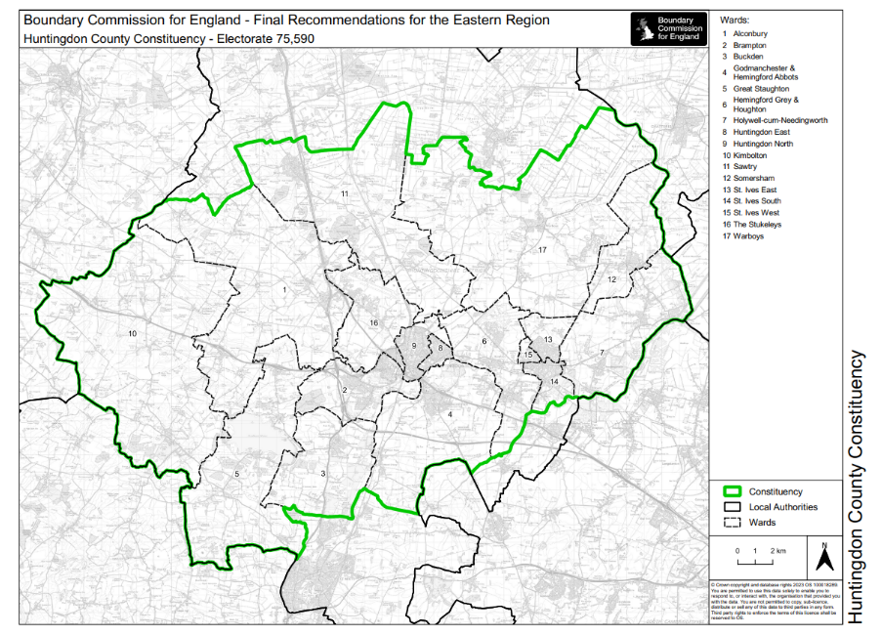
2023 Parliamentary Boundary Review

The Boundary Commission for England has submitted the final report to the Speaker of the House of Commons and the report has been laid in Parliament.

Boundary Commission for England | The Commission is required by the Parliamentary Constituencies Act 1986 to review the Parliamentary constituencies in England every five years (independent.gov.uk)

Meet Your Councillor Sessions
We understand that sometimes it is easier to talk to someone face to face, rather than send an email or make a phone call. To help, we have scheduled some dates where residents can come and meet their District and County councillors face to face. These will be split monthly across the three district wards.
Saturday 2nd September 14.30 - 15.30 Hemingford Abbots Village Hall
Saturday 7th October 14.30 – 15.30 Judith’s Field
Saturday 4th November 14.30-15.30 Offord Village Hall
As always, we work for you year-round. Should you need us, please contact us on:
Debbie Mickelburgh debbie.mickelburgh@huntingdonshire.gov.uk 07537 121365
Brett Mickelburgh brett.mickelburgh@huntingdonshire.gov.uk 07441 392492
Sarah Conboy sarah.conboy@huntingdonshire.gov.uk 01480 414900
***********
2023/3236 Finance, Risk Assessment & General Purposes

3236.1 To approve the monthly accounts.
The accounts were approved as an accurate record
3236.2 To approve the balance sheet.
The Balance Sheet was approved and signed.

2023/3237 To approve the following payments and sign the cheques.
The following payments were approved and where necessary, cheques signed.
Signed between meetings:

102461 Grassmats Limited Mesh for St Peters £226.80
102462 Toilets + Summer Sports Toilet Hire £345.42

To be signed at the meeting:
102463 Magpas UK Donation (S137) £100.00
102464 Easiprint Millennium Green Signage £73.05
102465 Hunts DC Waste Bags £117.00
102466 Antony Abbs Grass Cutting £540.0
102467 Mrs J Stanbridge Salary £416.22
102468 HMRC Tax & N.I. £63.18
2023/3238 Broadband
Cllr Young reported that Gigaclear were now working in Buckden but no date had been set for Offords yet. Cllr Savage informed Members that Openreach would not now be bring FFTP from Buckden due to permissions required from Network Rail.

2023/3239 Flooding (update if available)
It was noted that the brook would again be cleared in October to alleviate any potential flood issues.

2023/3240 Leisure & Amenities
Cllr Gatward reminded Members of the pond report received which would be discussed at the L&A meeting the following Thursday.
2023/3241 Planning
Cllr Young informed Members that the applications at 67 High Street, Great Parlow Close and 9 Elm Drive had been approved.

3241.1 Local Plan Update – Council’s Response
Cllr Weitzel thanked the Clerk for going through all 104 questions of the document. He had prepared a response to the relevant questions which had been circulated to all. Cllr Young to go through this and prepare the final response for HDC.

2023/3242 Chairman’s Report
The Chairman firstly thanked the prospective councillors for attending the meeting and introduced existing Cllrs and clerk to them. He commented that he hoped they had found the meeting interesting and that they would return for the co-option process at the August 3 meeting.

He spoke about the virtual meeting he had attended re the new East West Rail proposals and the effects they would have on the residents of Tempsford. He also spoke about the Cambridge congestion charge proposals and how The Offords were not included on any of the transport maps.

Lastly he spoke about the need for a bollard to be placed at the footpath from Andrews Close onto Paxton Road as many residents from Andrews Close were driving over this to access the Paxton Road creating a very dangerous situation. He asked the Clerk to report this to CCC highways.

2023/3243 Councillor Reports

Cllr Dawson: Asked for letters to be delivered to those properties whose hedges were overhanging the footpaths.

Cllr Savage: Spoke about the Community Ownership Fund and wondered if that could be used by All Saints church to renovate the Church Rooms. It was felt that the Church wanted to sell the Church Rooms and site and use the funds to repair the Church roof but the Clerk was asked to inform John Simpkin about the fund.

She also raised the issue of the blocked drain on the High Street and the other drains on Graveley Road. The Clerk was asked to report them.

2023/3244 Any Urgent Business
In accordance with section 100(B)(4) of the Local Government Act 1972 (as amended) the Chair will admit an item of urgent business in order that it can be dealt with at the earliest opportunity provided it has been raised at least 24 hours before the meeting.
None

2023/3245 The meeting closed at 9.30pm and next meeting date confirmed as Thursday August 3rd,2023, at 7.30pm, in the Village Hall, Offord Cluny

